Nikon Release Button
By Emile van der Laan
www.emsign.nl

This is a simple and small Infrared remote control for the Nikon D60 and some other Nikon cameras.

Schematic.
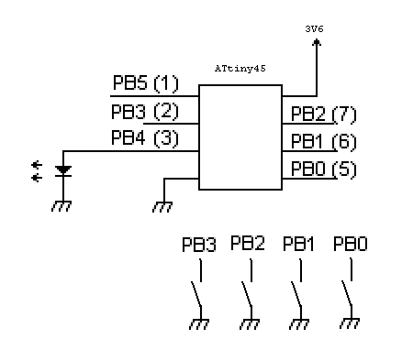

Proto type
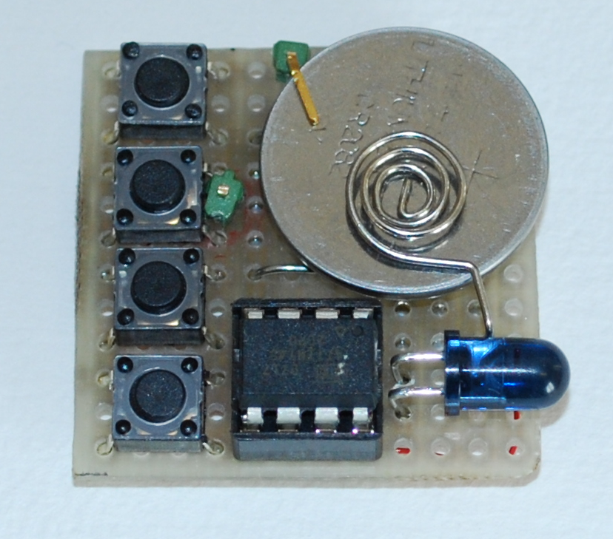

How it works.

The Nikon has an IR shutter release. This is activated by the flowing sending the following pulses on 36 Khz.

This is the Shutter release of a Nikon
2.0ms on * 36 Khz = 72 Pulse
28ms off * 36 Khz = 1008 Pulse
0.5ms on * 36 Khz = 18 Pulse
1.5ms off * 36 Khz = 54 Pulse
0.5ms on * 36 Khz = 18 Pulse
3.5ms off * 36 Khz = 126 Pulse
0.5 ms on * 36 Khz = 18 Pulse
Repeated after a 63.0 ms pause = 2268 Pulse

User Manual

PB0 Switch is once and Power off
PB1 Ever Second for max 1 hour
PB2 Ever 10 Second for max 1 hour
PB3 Ever minute for max 1 hour

Do not forget to cover up the viewer, as light will come in the wrong side of the camera.

